This document includes:

1. How to tag the review as approved for using RoB 2
2. RoB 2 considerations for protocol development
3. RoB 2 considerations for review reporting

**Document version control - *this document is draft as further RevMan Web developments are underway to improve processes and reporting.***

|  |  |
| --- | --- |
| **Document created:** | December 2020 |
| **Document last updated:** | March 2021. |
| **Document version:** | V1 was released is December 2020. V2 updates links to the riskofbias.info website and options for the detailed risk of bias assessments data. |
| **Version notes** |  |
| **Document author:** | Ella Flemyng (Methods Implementation Manager) |
| **Contact for queries:** | [eflemyng@cochrane.org](mailto:eflemyng@cochrane.org) |

It is the Cochrane Review Group’s decision as to whether a specific review can use RoB 2. More details about the [status and expectations of implementation of Risk of Bias 2 in Cochrane intervention reviews are available in this statement from the Editorial Board](https://community.cochrane.org/news/status-and-expectations-implementation-risk-bias-2-cochrane-intervention-reviews).

The following diagram showcases the process and support available for Cochrane Reviews using RoB 2, from title registration to publication of the Review (steps in darker colour highlight the additional support available for the first Review in a Cochrane Review Group that uses RoB 2):

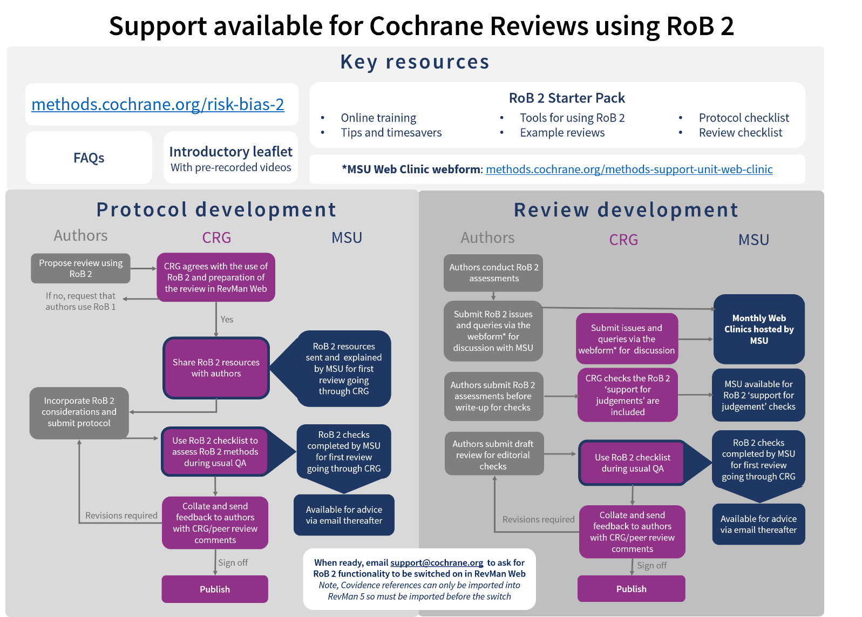

# **How to tag the Review as approved for using RoB 2**

The Cochrane Review Group can add a note to the review properties in Archie (as seen below). This will be helpful for Community Support, the Methods Support Unit, and copy editors checking the Methods section and Handbook references.

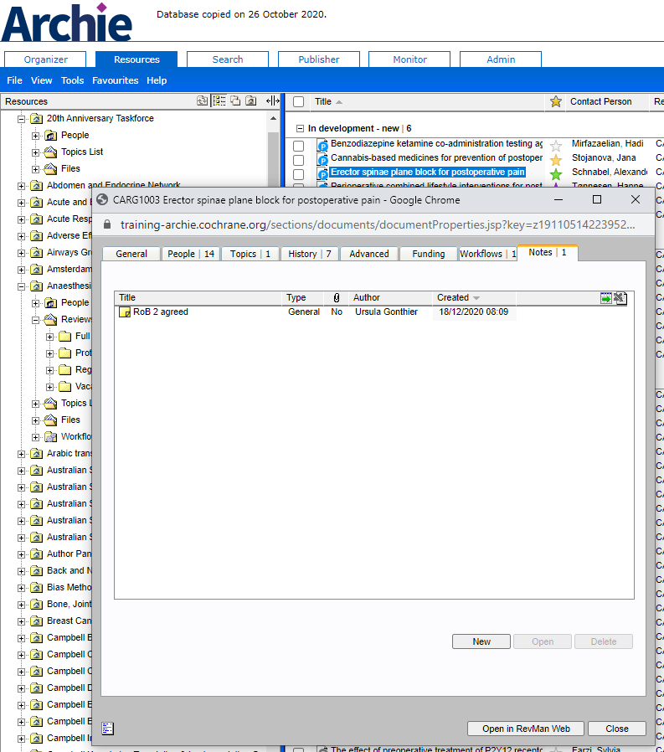

# **RoB 2 considerations for protocol development**

There are ten key items to consider when using the RoB 2 tool:

*A list of these items in a format that is easy to copy and paste to send to authors is at the end of this document.*

*When assessing these points in Cochrane Protocols, some Cochrane Review Group have added a third column to note whether the point has been completed or what is missing.*

|  |  |
| --- | --- |
| What to report | Further details |
| ***Methods section*** - ‘**Assessment of risk of bias in included studies’** | |
| 1. State that RoB 2 tool will be used and reference it | Reference [Sterne et al 2019 BMJ paper](https://www.bmj.com/content/366/bmj.l4898) and / or [Cochrane Handbook (version 6) Chapter 8](https://training.cochrane.org/handbook/current/chapter-08) .  **Guidance**: [MECIR PR27](https://community.cochrane.org/mecir-manual/standards-reporting-protocols-new-cochrane-intervention-reviews-pr1-pr44/reporting-review-plan-pr1-pr44/data-collection-and-analysis-pr22-pr40) |
| 2. State your effect of interest - effect of assignment or effect of adherence | **Guidance**: [Section 1.3 Detailed guidance](https://www.riskofbias.info/welcome/rob-2-0-tool/current-version-of-rob-2) (Riskofbias.info); [Section 8.2.2](https://training.cochrane.org/handbook/current/chapter-08#section-8-2-2) Cochrane Handbook. |
| 3. List or refer to the results that will be assessed using RoB 2, inc. outcome(s), outcome measure(s) and timepoint(s) | **Guidance**: [Section 1.3 Detailed guidance](https://www.riskofbias.info/welcome/rob-2-0-tool/current-version-of-rob-2) (Riskofbias.info); [Section 7.3.2](https://training.cochrane.org/handbook/current/chapter-07#section-7-3-2), [Section 8.2.1](https://training.cochrane.org/handbook/current/chapter-08#section-8-2-1) and [Section 8.7](https://training.cochrane.org/handbook/current/chapter-08#section-8-7) Cochrane Handbook. |
| 4. (If applicable) State how you will handle crossover RCTs and cluster RCTs | Reference the RoB variant for crossover trials and/ or the RoB 2 variant for cluster trials.  **Guidance**: [RoB for for crossover trials via riskofbias.info](https://sites.google.com/site/riskofbiastool/welcome/rob-2-0-tool/rob-2-for-crossover-trials?authuser=0) and [RoB 2 for cluster trials via riskofbias.info](https://sites.google.com/site/riskofbiastool/welcome/rob-2-0-tool/rob-2-for-cluster-randomized-trials?authuser=0)  ***NB****: Please note, as of December 2020, the cluster and cross trial variants for RoB 2 have not been developed in RevMan Web yet so there is interim guidance on how to display these results.*  ***NB****: Please note, if you have intended from the OUTSET to ONLY use data from the first period of the crossover, then you can use the standard version of RoB 2 as it is. However, please be alert to the potential impact of selective reporting of first period of data only when carry over is detected by trialists. Omission of trials which do not report first period data may lead to bias at the meta-analysis level. For details are in* [*Section 23.2*](https://training.cochrane.org/handbook/current/chapter-23#section-23-2) *Cochrane Handbook.* |
| 5. State who will assess RoB2 (initials), how many and whether independently and duplicate | **Guidance**: [MECIR C53](https://community.cochrane.org/mecir-manual/standards-conduct-new-cochrane-intervention-reviews-c1-c75/performing-review-c24-c75/assessing-risk-bias-included-studies-c52-c60); [Section 7.3.2](https://training.cochrane.org/handbook/current/chapter-07#section-7-3-2) Cochrane Handbook. |
| 6. List the domains of the tool | **Guidance**: [Section 1.3 of full, detailed guidance document](https://sites.google.com/site/riskofbiastool/welcome/rob-2-0-tool/current-version-of-rob-2?authuser=0) (Riskofbias.info); [Section 8.2.3](https://training.cochrane.org/handbook/current/chapter-08#section-8-2-3) Cochrane Handbook. |
| 7. List the judgment options (High, Some Concerns, Low) and how overall risk of bias is reached, e.g. using the signalling questions/tool algorithms | **Guidance**[: Section 1.1, Section 1.2.1 and Section 1.2.3 of full, detailed guidance document](https://sites.google.com/site/riskofbiastool/welcome/rob-2-0-tool/current-version-of-rob-2?authuser=0) (Riskofbias.info); [Section 8.2.3](https://training.cochrane.org/handbook/current/chapter-08#section-8-2-3) and [Section 8.2.4](https://training.cochrane.org/handbook/current/chapter-08#section-8-2-4) Cochrane Handbook. |
| 8. State if you plan to use any tools to manage the assessment of bias using RoB 2 | For example, the RoB2 Excel tool to implement RoB 2 (available on the [riskofbiasinfo.org](https://sites.google.com/site/riskofbiastool/welcome/rob-2-0-tool/current-version-of-rob-2?authuser=0) website)  **Guidance**: [MECIR C54](https://community.cochrane.org/mecir-manual/standards-conduct-new-cochrane-intervention-reviews-c1-c75/performing-review-c24-c75/assessing-risk-bias-included-studies-c52-c60); [Section 7.3.2](https://training.cochrane.org/handbook/current/chapter-07#section-7-3-2) Cochrane Handbook. |
| ***Methods*** ***section*** - ‘**Data synthesis’** | |
| 9. State whether the primary analysis will include all eligible studies or only those which have low risk of bias, or low risk and some concerns | This may depend on the number of studies with each risk of bias rating as you’ll need sufficient numbers for the analyses. It could also be appropriate to pool data from studies at high risk of bias and use a sensitivity analysis to assess the effects of restricting the analysis to RCTs overall ‘low’ or ‘low/some concerns’.  **Guidance**: [MECIR C21](https://community.cochrane.org/mecir-manual/standards-conduct-new-cochrane-intervention-reviews-c1-c75/developing-protocol-review-c1-c23/planning-review-methods-protocol-stage-c19-c23), [Section 7.6.2](https://training.cochrane.org/handbook/current/chapter-07#section-7-6-2) Cochrane Handbook. |
| ***Methods*** ***section*** - ‘**Subgroup analysis and investigation of heterogeneity’** | |
| (If applicable) Specify if subgroup analysis is planned based on risk of bias | Consider whether overall risk of bias should be used as the basis for any subgroup analysis. **Guidance**: [MECIR C22](https://community.cochrane.org/mecir-manual/standards-conduct-new-cochrane-intervention-reviews-c1-c75/developing-protocol-review-c1-c23/planning-review-methods-protocol-stage-c19-c23); [Section 10.11.2](https://training.cochrane.org/handbook/current/chapter-10#section-10-11-2)  and [Section 7.6.2](https://training.cochrane.org/handbook/current/chapter-07#section-7-6-2) Cochrane Handbook. |
| ***Methods*** ***section*** - ‘**Sensitivity analysis’** | |
| (If applicable) Specify if sensitivity analysis is planned based on risk of bias | Consider whether overall risk of bias should be used as the basis for any sensitivity analysis. **Guidance**: [MECIR C71](https://community.cochrane.org/mecir-manual/standards-conduct-new-cochrane-intervention-reviews-c1-c75/performing-review-c24-c75/synthesizing-results-included-studies-c61-c73); [Section 10.14](https://training.cochrane.org/handbook/current/chapter-10#section-10-14) and [Section 7.6.2](https://training.cochrane.org/handbook/current/chapter-07#section-7-6-2) Cochrane Handbook. |
| ***Methods section*** - ‘**Summary of findings and assessment of the certainty of the evidence’** | |
| 10. State how the RoB 2 assessment will be used to assess the certainty of the evidence/ GRADE/ SoF | State that the *overall* RoB2 judgement will be used to feed into the GRADE assessment.  **Guidance**: [MECIR C54](https://community.cochrane.org/mecir-manual/standards-conduct-new-cochrane-intervention-reviews-c1-c75/performing-review-c24-c75/assessing-risk-bias-included-studies-c52-c60); [Section 7.3.2](https://training.cochrane.org/handbook/current/chapter-07#section-7-3-2) Cochrane Handbook. |
| ***Other considerations*** | Authors should not adapt the RoB 2 tool.  State how you will store and present your detailed RoB2 data - the RoB 2 tool may generate a large amount of data. Authors can either state in their Review that these data are available upon reasonable request, or ideally, the consensus decisions for the signalling questions are made publicly available so your rational for judgements is transparent. This can be stored as supplemental data or files (see the [Editorial and Publishing Policy for full details](https://documentation.cochrane.org/display/EPPR/Supplemental+data+and+files)).  **Guidance**: [MECIR C54](https://community.cochrane.org/mecir-manual/standards-conduct-new-cochrane-intervention-reviews-c1-c75/performing-review-c24-c75/assessing-risk-bias-included-studies-c52-c60); [Section 7.3.2](https://training.cochrane.org/handbook/current/chapter-07#section-7-3-2) Cochrane Handbook.  See this published protocol as an example:   * [Contraception decision aids to improve care and effective method use](https://doi.org/10.1002/14651858.CD013659) (missing Point 8 – whether they have plans to use any tools to manage the assessment of bias using RoB 2) |

***Example protocol feedback for authors (if they had not included any risk of bias information):***

***Methods section*** - ‘**Assessment of risk of bias in included studies’**

1. State that RoB 2 tool will be used and reference it

2. State your effect of interest - effect of assignment (ITT) or effect of adherence (per protocol)

3. List or refer to the results that will be assessed using RoB 2, inc. outcome(s), outcome measure(s) and timepoint(s)

4. (If applicable) State how you will handle cluster RCTs and cross-over RCTs

5. State who will assess RoB2 (initials), how many and whether independently and duplicate

6. List the domains of the tool

7. List the judgment options (High, Some Concerns, Low) and how overall risk of bias is reached, e.g. using the signalling questions/tool algorithms

8. State if you plan to use any tools to manage the assessment of bias using RoB 2

***Methods*** ***section*** - ‘**Data synthesis’**

9. State whether the primary analysis will include all eligible studies or only those which have low risk of bias, or low risk and some concerns

***Methods section*** - ‘**Summary of findings and assessment of the certainty of the evidence’**

10. State how the RoB 2 assessment will be used to assess the certainty of the evidence/ GRADE/ SoF

# **RoB 2 considerations for review reporting**

There are seven key items to consider when reporting RoB 2 in the full review:

*A list of these items in a format that is easy to copy and paste to send to authors is at the end of this document.*

*When assessing these points in Cochrane Reviews, some Cochrane Review Group have added a third column to note whether the point has been completed or what is missing.*

|  |  |
| --- | --- |
| **What to report** | **Further details** |
| ***Methods*** - ‘**Assessment of risk of bias in included studies’** | |
| 1. Include all the RoB 2 considerations from the Protocol. | Compare the Review to the Protocol to ensure they are consistent (it may be useful to assess the reporting against the protocol checklist for RoB 2 to ensure everything was included originally).  If there were any deviations from the Protocol, these should be detailed in the ‘Differences between protocol and review’ section (see below). |
| 1. State the version of the RoB 2 tool that was used. | The [riskofbias.info website lists the current version](https://sites.google.com/site/riskofbiastool/welcome/rob-2-0-tool/current-version-of-rob-2?authuser=0) and archived versions of the RoB 2 tool. Ensure you state which version of the tool you used, e.g. when this guidance was created the 2019 version was the current version with the full guidance was published on 22 August 2019. |
| ***Results*** - ‘**Risk of bias in included studies’** | |
| 1. Refer to the results-level RoB 2 tables, which includes the support for judgement for each domain assessment. | The results-level RoB 2 tables are located in the ‘Risk of bias’ section after the characteristics of studies section.  Each outcome prespecified for risk of bias assessments (likely to be the reviews’ critical and important outcomes included in the SoF table) should have a table that includes the risk of bias judgements (high, low or some concerns) and the support each judgement  **Guidance**: How to create and view the Risk of bias tables is detailed in the RevMan Web Knowledge Base (see [RoB 2 in RevMan Web](https://documentation.cochrane.org/revman-kb/risk-of-bias/risk-of-bias-2-in-revman-web)).  A screenshot of a cell phone  Description automatically generated  In certain circumstances, authors may wish to use other figures that best present the risk of bias data, e.g. weighted risk of bias bar plots can provide a succinct summary when there are lots of studies in a synthesis. |
| 4. State how to access detailed risk of bias assessments data (with consensus responses to the signalling questions). | Authors should either state that these data are available upon reasonable request, or ideally, the consensus decisions for the signalling questions have been made publicly available and are cited in the main text as supplemental data or files (they should not be included within the Review itself). **Guidance**: [Supplemental data and files’ in the Editorial and Publishing Policy Resource](https://documentation.cochrane.org/display/EPPR/Supplemental+data+and+files). |
| 5.Provide a brief overview of the risk of bias assessments. | Consider ***overall comments on key aspects*** of the risk of bias assessments, e.g. the quality of randomization and extent to which blinding was implemented.  Consider whether there are ***important differences*** in risk of bias by outcome.  If ***risk of bias assessments are very similar*** (or identical) for all outcomes in the review, a summary of the assessments across studies should be presented here.  If ***risk of bias assessments are very different*** for different outcomes, this section should be very brief, and summaries of the assessments across results should be discussed with other GRADE considerations in the Discussion (see point 7 below). |
| ***Results*** - ‘**Effects of intervention’** | |
| 6. Refer to visual representations of the risk of bias assessments in relation to each result. | Using forest plots with traffic lights is highly recommended (reference this from the Analyses section – you do not need to add additional Figures).  **Guidance**: How to create and view forest plots with traffic lights in Analyses is detailed in the RevMan Web Knowledge Base (see [RoB 2 in RevMan Web](https://documentation.cochrane.org/revman-kb/risk-of-bias/risk-of-bias-2-in-revman-web)).  It may be very helpful to stratify forest plots according to overall risk of bias.    For synthesis without meta-analysis, we recommend that a column is added to any visual representation of the data that highlights the overall risk of bias associated with each of the results in the table/figure, e.g.:      **Guidance**: [Section 7.6](https://training.cochrane.org/handbook/current/chapter-07#section-7-6) Cochrane Handbook |
| (If applicable) Give results of additional analyses (e.g., meta-regression). |  |
| ***Results*** - ‘**Subgroup analysis’** | |
| (If applicable) Discuss any subgroup analysis conducted that relates to the risk of bias judgments. |  |
| ***Results*** - ‘**Sensitivity analysis’** | |
| (If applicable) Discuss any sensitivity analysis conducted that relates to the risk of bias judgments. |  |
| ***Discussion*** -**’Certainty of the evidence’** (previously the ‘Quality of the evidence’ section | |
| 7. Discuss any risk of bias judgements that affect the certainty of the evidence along with all other GRADE considerations. | Along with the other GRADE considerations, ***highlight any important implications*** from the risk of bias assessments for each of the outcomes prespecified for risk of bias assessments (likely to be the reviews’ critical and important outcomes included in the SoF table), such as whether the risk of bias assessments results in downgrading the certainty of the evidence for a specific outcome and whether the effects of the intervention may need to be interpreted with caution.  **Guidance**: [Section 7.5](https://training.cochrane.org/handbook/current/chapter-07#section-7-5) and [Section 14.2.2](https://training.cochrane.org/handbook/current/chapter-14#section-14-2-2) Cochrane Handbook |
| ***History*** – **‘Differences between protocol and review’** | |
| (If applicable) State if there were any deviations from the Protocol. | **Guidance**: [MECIR R107 and R108](https://community.cochrane.org/mecir-manual/standards-reporting-new-cochrane-intervention-reviews-r1-r109/results-r56-r109/differences-between-protocol-and-review-r107-r108). |
| ***Other considerations*** | See this published review as an example:  • [Physical activity interventions for people with congenital heart disease](https://www.cochranelibrary.com/cdsr/doi/10.1002/14651858.CD013400.pub2/full) |

***Example review feedback for authors (if they had not included any risk of bias information):***

***Methods section*** - ‘**Assessment of risk of bias in included studies’**

1. Include all the RoB 2 considerations from the Protocol.
2. State the date that the RoB 2 tool was accessed.

***Results*** - ‘**Risk of bias in included studies’**

1. Refer to the results-level RoB 2 tables.
2. State how to access detailed risk of bias assessments data (with consensus responses to the signalling questions).
3. Provide a written overview of the risk of bias assessments.

***Results*** - ‘**Effects of intervention’**

1. Refer to visual representations of the risk of bias assessments in relation to each result.

***Discussion*** -**’Certainty of the evidence’**

1. Discuss any risk of bias judgements that affect the certainty of the evidence along with all other GRADE considerations.